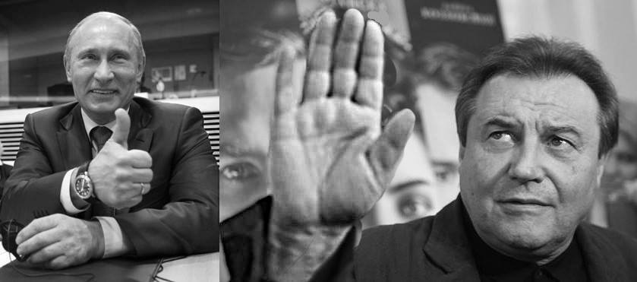

***MOVIE DIRECTOR ALEXEI UCHITEL SIGNED A LETTER IN SUPPORT OF ANNEXATION OF CRIMEA AND PUTIN’S POLICY TOWARD UKRAINE***

On March 11, 2014, a group of Russian cultural figures signed an open letter titled "Russian cultural figures in support of the President's policy toward Ukraine and Crimea." (The letter is available at the official web site of the Ministry of Culture of the Russian Federation: <http://old.mkrf.ru/press-center/news/ministerstvo/deyateli-kultury-rossii-v-podderzhku-pozitsii-prezidenta-po-ukraine-i-krymu?sphrase_id=6926619>. English translation is available here: <http://russianartists4war.com/letter/>).

Among those who signed the letter willfully and voluntarily is movie director Alexey Uchitel (signature number 441). His film *Matilda* is screening at the Tribeca Performance Arts Center today, and the director will appear for Q&A after the screening.

Putin’s policies toward Ukraine that were enthusiastically supported by Uchitel, have resulted in over 10,000 dead, including 298 passengers of the Malaysian Airlines Flight 17 murdered by a Russian BUK missile, hundreds of thousands injured, and millions displaced. However, in the well over three years since, and despite mounting human and infrastructure costs, Mr. Uchitel has not taken any steps to repudiate the policy or to withdraw his signatures. As of November 14th 2016, the International Criminal Court recognized Putin's policies in Ukraine and Crimea as crimes. In light of this development, it is plain to see that Mr. Uchitel is on-the-record supporter of war crimes.

Mr. Uchitel is certainly entitled to his own political views. But it is an outrage when he has been using his artistic reputation as a bully pulpit to praise and whitewash the Kremlin’s invasion of Ukraine.

Our protests, held internationally, are ethical rather than political. They are intended to inform the international community of hypocrisy, cynicism, and perfidy of the signatories of that despicable letter, which gives sanctimonious approval to actions which have deliberately inflicted thousands of deaths, hundreds of thousands of injuries, and displaced millions of people and violated the human rights of tens of millions.

In 1945 Thomas Mann wrote: "If at that time the whole German intelligentsia, all those whose names were known in Germany had risen as one man against infamy and disgrace, if they had proclaimed a general strike, if they had left the country - that would have made a deep impression, at home and abroad, and much of what happened later could have been different."

[SIGNERBUSTERS]