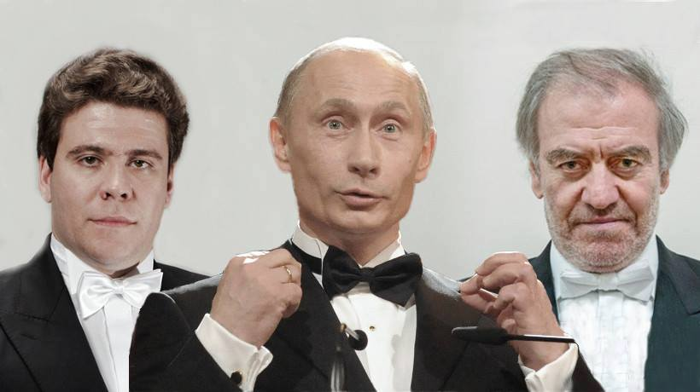

In March 2014, both Gergiev and Matsuev were among 511 Russian cultural figures who signed a letter in support of the policies of the Russian President Putin on Ukraine and Crimea. (The letter is available at the official web site of the Ministry of Culture of the Russian Federation: <https://www.mkrf.ru/press/news/deyateli-kultury-rossii-v-podderzhku-pozitsii-prezidenta-po-ukraine-i-krymu20171009103201/>. English translation is available here: <https://russianartists4war.com/letter/>.

These policies have since resulted in thousands dead, including 298 passengers of the Malaysian Airlines Flight 17 murdered by a Russian BUK missile, hundreds of thousands injured, and millions displaced. However, in the well over three years since, and despite mounting human and infrastructure costs, Mr. Gergiev and Mr. Matsuev have not taken any steps to repudiate the policy or to withdraw their signatures. As of November 14th 2016, the International Criminal Court recognized Putin's policies in Ukraine and Crimea as crimes. In light of this development, it is plain to see that Mr. Gergiev and Mr. Matsuev are on-the-record supporters of war crimes.

It is important to note that while Mr. Gergiev and Mr. Matsuev and other artists loyal to the regime enjoy the many perks of being favored by an autocrat and his machinery of state, the same machinery has been repeatedly used to punish artists who aim to bring public awareness to regime's crimes. Meanwhile, Putin’s confidante, Mr. Gergiev was appointed an Honorary Member of the Community Council of the Investigative Committee of Russia, a federal governmental agency controlled by President Putin, which is notorious in today’s Russia as a new punitive body responsible for serial human rights violations.

Presenting criminal regime as being cultural and civilized has been a well-known signature move of Russian propaganda machine since the Soviet era. Now it’s being successfully employed to establish “soft power” through cultural influence to promote Putin's Russia.

Mr. Gergiev and Mr. Matsuev are certainly entitled to their own political views. But it is an outrage when they have been using their artistic reputation as a bully pulpit to praise and whitewash the Kremlin’s invasion of Ukraine.

Our protests, held internationally, are ethical rather than political. They are intended to inform the international community of hypocrisy, cynicism, and perfidy of the signatories of that despicable letter, which gives sanctimonious approval to actions which have deliberately inflicted thousands of deaths, hundreds of thousands of injuries, and displaced millions of people and violated the human rights of tens of millions.

[SIGNERBUSTERS]