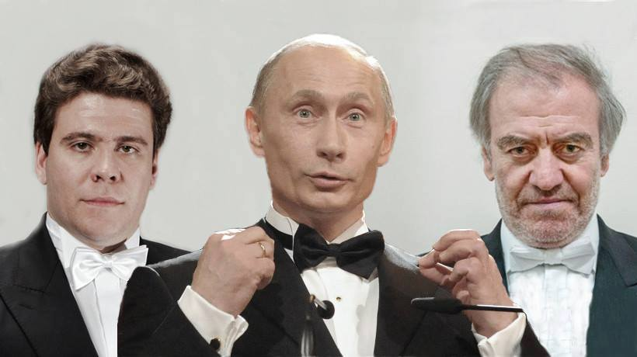

On March 11, 2014, a group of Russian cultural figures signed an open letter titled "Russian cultural figures in support of the President's policy toward Ukraine and Crimea." (The letter is available at the official web site of the Ministry of Culture of the Russian Federation: <https://www.mkrf.ru/press/news/deyateli-kultury-rossii-v-podderzhku-pozitsii-prezidenta-po-ukraine-i-krymu20171009103201/>. English translation is available here: <https://russianartists4war.com/letter/>.

The list of signatories includes 511 individuals. With their signatures, these celebrities express their support for:

* Annexation of territory of the independent state of Ukraine in violation of international law (subsequently condemned by United Nations Resolution GA/11493).
* Killing and injury of many thousands of soldiers and civilians in the war waged by the Kremlin strategists in the Eastern Ukraine.
* Destruction of property and the dislocation of millions of civilians in the occupied territory.
* Promulgation of false propaganda at an unprecedented scale.

Among those who signed the letter willfully and voluntarily is Valery Gergiev (his signature is number 97) and Denins Matsuev (signature number 270) who will perform at the Carnegie Hall tonight.

All of the acts supported in the policy letter are justified under the slogan ***"Our culture and its spiritual origins, Our foundational values."*** The letter is replete with repetitions of the word ***"our".*** But it is manifest for any who have eyes to see that the values the letter supports are not universal human values.

By signing this letter, the signatories have given their imprimatur to the tactic of using "human shields" admitted openly by Russian President Putin: *"****Let someone from the [Ukrainian] military dare to shoot at their own people, whom we will stand behind. Not in front, but right behind. Let them dare to shoot at women and children.****"*

Naturally, Gergiev and Matsuev don’t advertise their avid support for the Kremlin’s aggressive policy toward a sovereign state here in the West. To the contrary, they portray themselves as the messengers of peace through culture while performing music. But back in Russia they stand for the policy of Might-Is-Right. As Putin’s confidante, Mr. Gergiev was appointed an Honorary Member of the Community Council of the Investigative Committee of Russia, a federal governmental agency controlled by President Putin, which is notorious in today’s Russia as a new punitive body responsible for serial human rights violations.

Mr. Gergiev and Mr. Matsuev are certainly entitled to their own political views. But it is an outrage when they have been using their artistic reputation as a bully pulpit to praise and whitewash the Kremlin’s invasion of Ukraine.

Here tonight we denounce Gergiev’s and Matsuev’s hypocrisy and perfidy in using art to promote war.

[SIGNERBUSTERS]